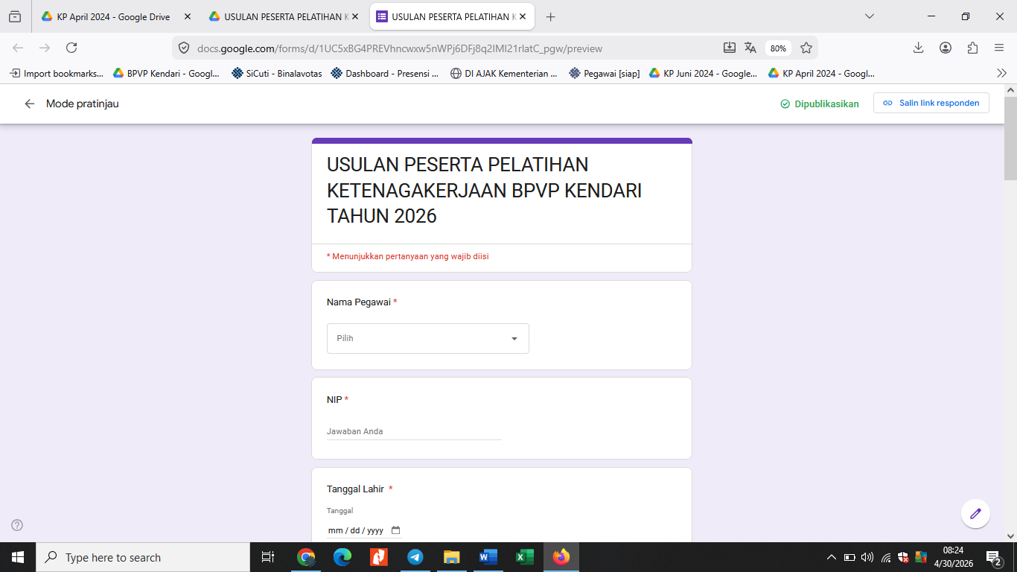
Link Usulan Pelatihan BPVP Kendari 2026 : https://forms.gle/WVQ9CGpeVPBRyt6v5

