MAPPING KOMPETENSI JF INSTRUKTUR BPVP KENDARI 2026
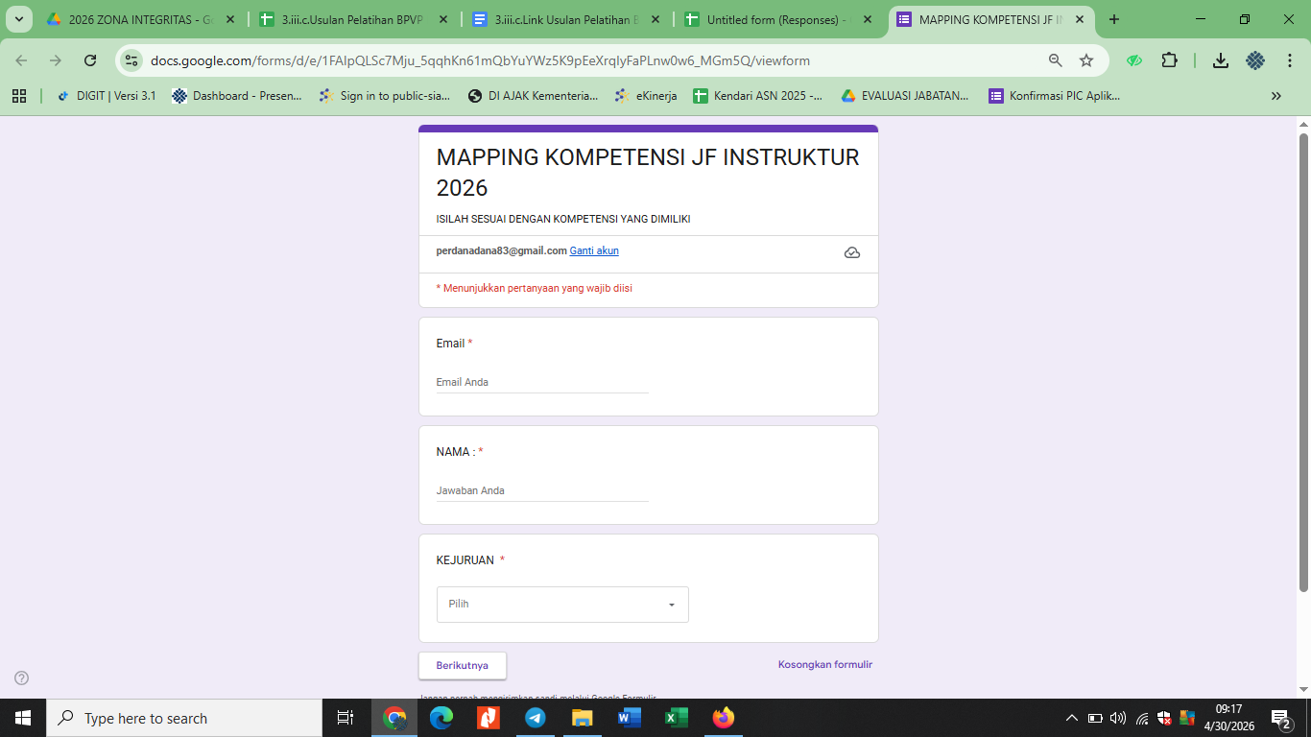
Link : https://forms.gle/ZU93smb2Wq9Kmj6V9

