LINK SOSIAL MEDIA BPVP KENDARI
- Instagram (https://www.instagram.com/bpvpkendari_official?igsh=Z21tMWVvcjk1eDVy)
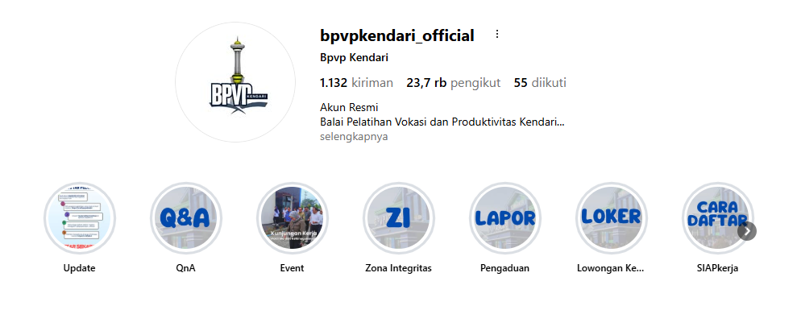
- Tiktok (https://www.tiktok.com/@bpvpkendari_official?_r=1&_t=ZS-95w7MtWDOGF)
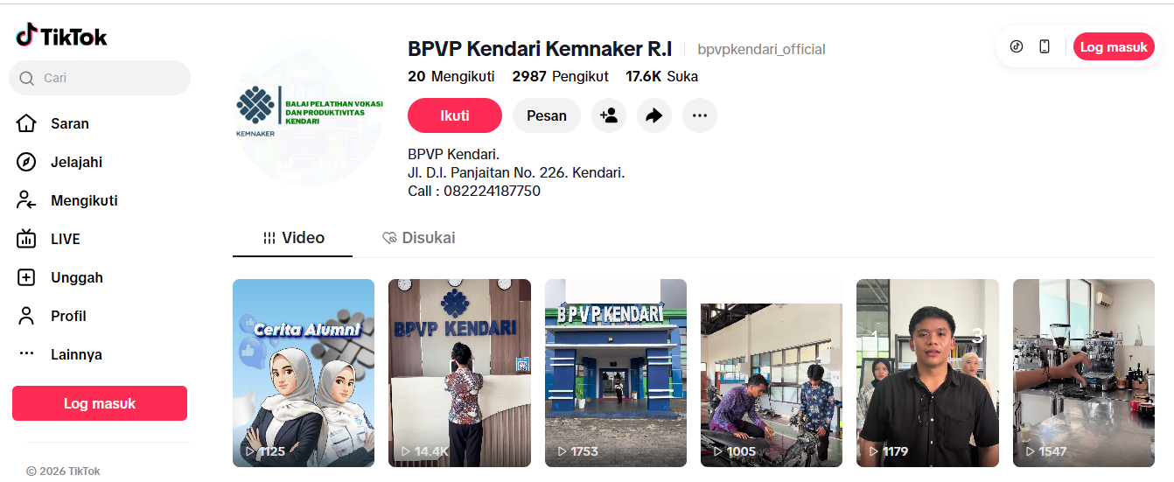

- Channel WA BPVP Kendari
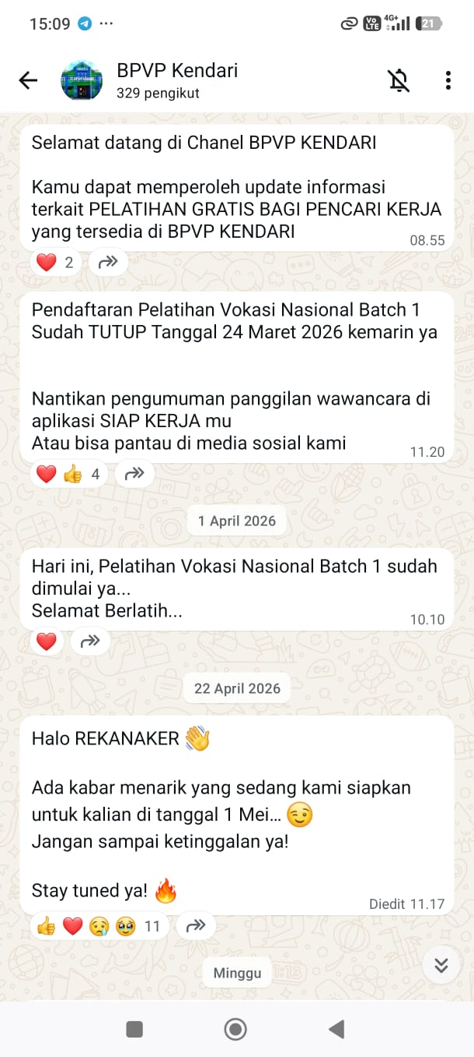
- Microsite BPVP Kendari (https://s.id/bpvpkendari)
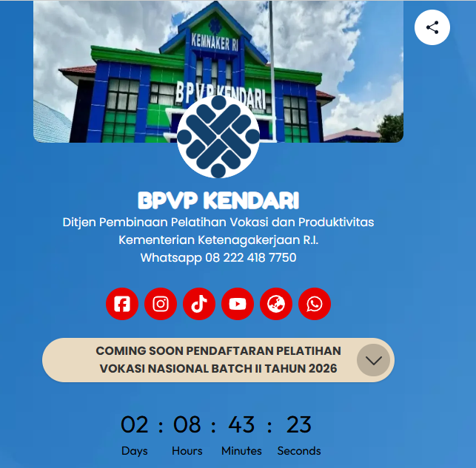
- Email BPVP KENDARI
bpvpkendari@kemnaker.go.id
- No Kontak yang bisa dihubungi :
Telepon: +6282224187750

- WhatsApp Kios SIAP Kerja (+6282224187750)
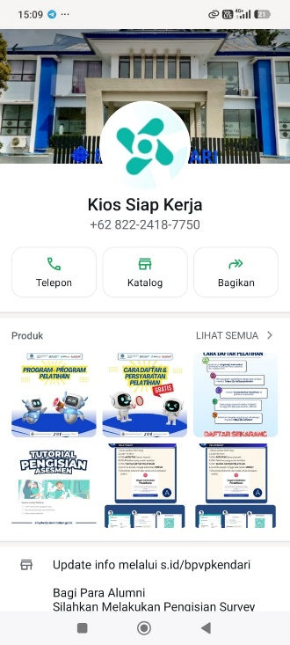
- Website BPVP Kendari (https://bpvpkendari.kemnaker.go.id/)
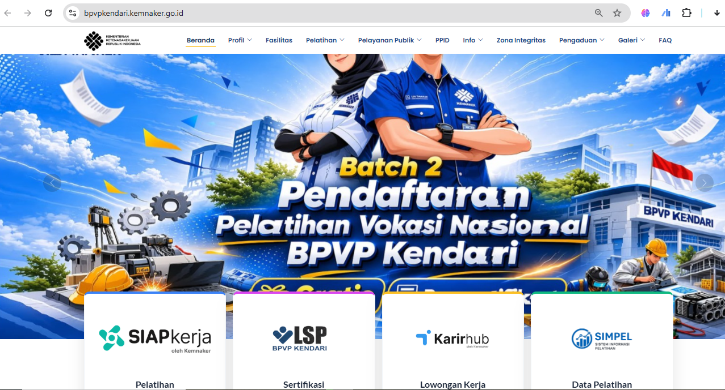

- Youtube BPVP Kendari (https://www.youtube.com/@bpvpkendari_official)
